**Project Title : “WorkSpace Management System”**

* **Team Name:** SpaceSync
* **Team Members:** Dhanush Dhanapal, Deekshith Gowda
* **Problem Statement:** A large company with thousands of employees is facing logistical issues in efficiently managing workspaces and parking slots. The existing process is manual, leading to miscommunication and resource wastage. Additionally, organizing internal events for employee engagement, such as competitions or team-building activities, becomes overwhelming without a proper system in place. A solution is needed that can automate these processes and help the company allocate resources and organize events smoothly.

**1. Understanding of the Problem Statement**

1. **Explanation of Problem Context:** The company is struggling to manage its workspaces, parking slots, and event spaces due to an outdated, manual process. The primary users of the solution are company employees and internal management teams. For employees, the solution should simplify the reservation of workspaces and parking slots, reducing time spent coordinating these logistics. Management teams will benefit from streamlined workflows to allocate resources and organize events like competitions or team-building activities, thus improving employee engagement. The system should ultimately enhance communication, reduce errors, and optimize resource usage across the organization. By automating these processes, the company aims to minimize resource wastage and improve the employee experience.
2. **Key Requirements Identified:**

* Workspace Management System:
* Allow employees to book workspaces based on availability, specific dates, and assigned projects.
* Implement an interface for administrators to view workspaces reservation effectively.
* Include a system to display current workspace availability and track historical usage for future planning.
* Parking Slot Reservation System:
* Enable employees to reserve parking slots ensuring each booking is unique and preventing double bookings.
* Provide real-time updates on parking slot availability to employees.
* EventSpace Management:
* Allow managers to create and organize internal events, specifying details such as name, participant count, and date required.
* User Authentication and Role-Based Access Control:
* Secure the system with user authentication, allowing employees to access relevant services and resources.
* Role-based access control should restrict certain functions to administrators or managers, ensuring data integrity and appropriate access.
* Data Insights and Reporting:
* Generate reports on workspace and parking usage as well as event reservations.
* Include real-time analytics to monitor usage trends and identify peak periods, allowing for optimized resource allocation.

**2. Solution overview**

**Solution Summary:**

The proposed solution is an automated reservation and resource management platform tailored to the company’s needs for managing workspaces, parking slots, and event spaces. By centralizing reservations and resource allocations, this platform streamlines booking processes, ensures real-time updates on availability, and automates event organization. Employees can easily reserve workspaces or parking slots based on current availability, while managers can efficiently set up internal events, monitor participation, and access insights for future planning. The solution's role-based access control secures data by ensuring that only authorized personnel can manage resources, while employees can view and book available spaces.

**Objectives**

* **Enhance Operational Efficiency:** Automate the management of workspaces, parking slots, and event spaces, reducing manual effort and streamlining workflows.
* **Improve Employee Experience:** Simplify the booking process for employees, saving time and reducing friction in managing daily workspace needs and parking arrangements.
* **Optimize Resource Utilization:** Provide real-time insights and analytics to ensure effective use of resources and prevent wastage.
* **Support Effective Event Management:** Facilitate the setup and management of internal events to encourage employee engagement and improve company culture.
* **Enable Data-Driven Decision Making:** Deliver actionable reports and analytics that help management make informed decisions on resource allocation, usage patterns, and future space planning.

**3. Features and Functionalities**

**a. Core Features:**

* **For Employees:**
* Workspace Reservation: Allows employees to reserve available workspaces for specific dates and projects.
* Parking Slot Reservation: Enables employees to book parking slots based on real-time availability, ensuring each reservation is unique and preventing double bookings.
* **For Managers:**
* Event Space Reservation: along with parking and workspace reservations managers will have the ability to create and manage internal events by specifying details like event name, participant count, and dates, thus improving coordination for team-building activities.
* **For Administrators:**
* User Management: Admins can update, or remove users, assign roles, and manage access control.
* Reservation Visualization: Access to an overview of all reservations across workspaces, parking, and event spaces to monitor usage patterns and optimize resource allocation.

**b. Additional Features:**

* **User Profile Management:**
* Allows users (employees, managers, and admins) to view and update their profile details, such as contact information, project roles, and preferred workspaces or parking slots.
* **Feedback Submission and Management:**
* Employees can submit feedback on their experience with workspace, parking, and event space bookings.
* Administrators can review and respond to feedback, fostering a proactive approach to improve the user experience.

**c. User flow:**

* **Employee Flow:**
* Login → Dashboard → Select Workspace or Parking Reservation → Choose available slot and date → Confirm reservation → Receive confirmation and reservation details.
* Profile Management → Access profile from dashboard → View or edit personal information.
* Submit Feedback → Access feedback option → Provide feedback on reservation experience → Submit feedback.
* **Manager Flow:**
* Login → Dashboard → Select Workspace, Parking, or Event Space Reservation → Choose resources based on team or project needs → Confirm booking and receive confirmation.
* Profile Management → View or edit personal information through profile settings.
* Submit Feedback → Option to provide feedback on reservation experiences for improvement.
* **Admin Flow:**
* Login → Admin Dashboard → Access User Management to update, or remove users and assign roles.
* Reservation Overview → Access real-time visualizations and reports on all reservations (workspace, parking, and event spaces).
* Feedback Management → View submitted feedback and respond to employees, ensuring issues are addressed and improvements are implemented.

**4. Architecture Diagram**

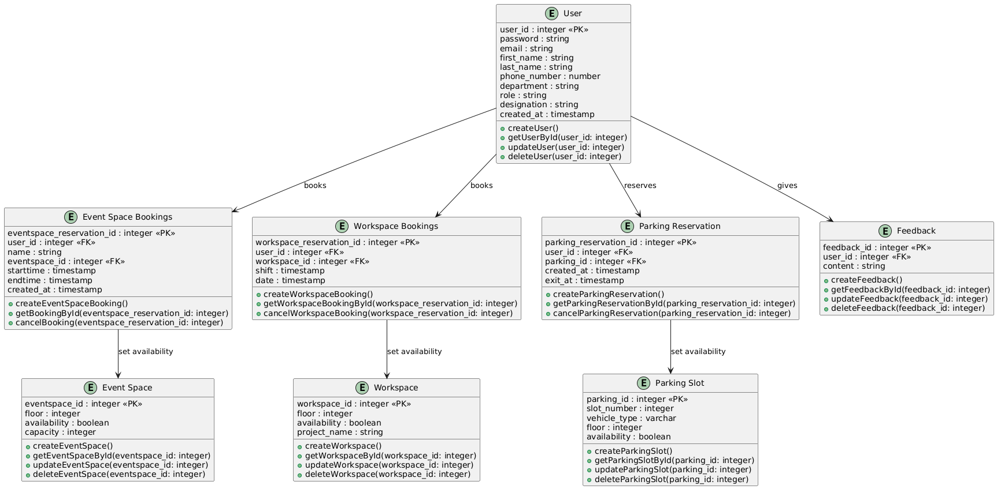

* **Classes**

The diagram contains the following classes:

* + User: Represents users of the system with attributes like ID, password, email, name, phone number, department, role, designation, and creation time.
    - EventSpaceBooking: Represents bookings for event spaces, with attributes like ID, user ID, event space ID, start time, end time, and creation time.
    - WorkspaceBooking: Represents bookings for workspaces, with attributes like ID, user ID, workspace ID, start time, end time, and creation time.
    - ParkingReservation: Represents parking reservations, with attributes like ID, user ID, parking ID, creation time, and exit time.
    - Feedback: Represents user feedback, with attributes like ID, user ID, content, and creation time.
    - EventSpace: Represents event spaces, with attributes like ID, floor, availability, capacity, and creation time.
    - Workspace: Represents workspaces, with attributes like ID, floor, availability, project name, and creation time.
    - ParkingSlot: Represents parking slots, with attributes like ID, slot number, vehicle type, floor, and availability.
* **Relationships**

The diagram shows the following relationships between classes:

* User has a one-to-many relationship with EventSpaceBooking, WorkspaceBooking, ParkingReservation, and Feedback. This means a user can make multiple bookings and provide multiple feedback.
* EventSpaceBooking, WorkspaceBooking, and ParkingReservation have a many-to-one relationship with EventSpace, Workspace, and ParkingSlot respectively. This means multiple bookings can be made for a single event space, workspace, or parking slot.

**5. Technical Stack**

* **Frontend:**
  + React with TypeScript: Used for a scalable, component-based UI that leverages type safety and better tooling.
  + Chakra UI: Provides responsive, accessible components and a cohesive design.
* **Backend:**
  + Node.js and Express with TypeScript: Backend framework for a scalable, maintainable server environment.
  + Separate microservices for Parking, Workspace, Event Space, and Authentication enable modular functionality.
  + RESTful APIs for CRUD operations and seamless frontend-backend communication.
* **Database**
  + MongoDB: Document-based database supporting high data volume and flexibility for reservations, user profiles, and event data.

**6. Prerequisites and Requirements**

* Technical Requirements:
  + Databases: Local MongoDB setup for data storage related to users, reservations, and feedback.
  + Development Environments: Local environment with Node.js, TypeScript, and React, along with IDEs like VSCode.
* Data Requirements:
  + Sample Data: Datasets for workspace, parking slot, and event reservations to simulate scenarios.
* Access Permissions:
  + Repositories: Access to GitHub or GitLab for version control.
* Other Dependencies:
  + Libraries: Chakra UI for UI components, JWT for authentication, and Mongoose for MongoDB.
  + Plugins/Packages: Required Node.js packages (e.g., Express, Axios) and specific versions of React, TypeScript, and MongoDB drivers.

**7. Future Improvements:**

* **Planned Enhancements:**
* Parking Space Security: Add security features like authentication and role-based access to prevent unauthorized bookings.
* Event Space Booking by Duration: Allow event space reservations based on specific time durations, not just dates.
* Multiple-Day Workspace Booking: Enable workspace reservations for multiple consecutive days.
* Admin Reservation Visualization: Allow admins to view and analyze reservation data across multiple days for better resource management.
* **Scalability Considerations:**
* Microservices Architecture: The solution's microservices architecture allows independent scaling of services (e.g., parking, workspace, event space) based on demand, ensuring efficient resource allocation as user load grows.
* Horizontal Scaling: By deploying multiple instances of microservices and using load balancing, the system can handle increased user traffic, improving responsiveness and reliability.
* Database Scalability: Implement database sharding or clustering in MongoDB to distribute data across multiple nodes, ensuring faster access and supporting higher volumes of reservations and user data.
* Caching: Use caching (e.g., Redis) for frequently accessed data like parking availability and workspace status, reducing database load and improving performance.

**8. Conclusion**

* **Summary of Achievements:**
  + The solution automates workspace, parking, and event space reservations, eliminating manual inefficiencies.
  + It uses microservices and MongoDB for scalability and ease of maintenance.
  + Secure user authentication and role-based access ensure proper access control.
  + Real-time availability updates enhance resource management.
* **Value Provided:**
  + Employees save time and reduce confusion by booking resources in a centralized system.
  + Managers can streamline event organization and resource allocation.
  + Admins gain insights into usage trends, improving operational efficiency.
  + The solution reduces resource wastage and optimizes workflow across the company.